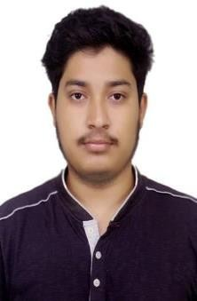CURRICULUM VITAE

Name: Debarchan Mondal Phone No.: 9064368953

Email: [mondaldebarchan801@gmail.com](mailto:mondaldebarchan801@gmail.com)

# Educational Qualification:

|  |  |  |  |  |
| --- | --- | --- | --- | --- |
| **Exam Passed** | **Year of**  **passing** | **University/Board** | **Main subject** | **Average of**  **marks (%)** |
| Secondary | 2013 | W.B.B.S.C. | BNGA, ENGB, MATH, PHY Sc, LIFE Sc, HIS, GEO | 65.43 |
| Higher secondary | 2015 | W.B.C.H.S.E. | BNGA, ENGB, BIOS, CHEM, NUTN, GEGR | 78.6 |
| B.SC (H) | 2018 | VIDYASAGAR UNIVERSITY | Nutrition (Hons), Chemistry (G), Physiology (G) | 68.75 |
| M.SC | 2020 | VIDYASAGAR UNIVERSITY | Clinical Nutrition and Dietetics | 82 |

**Current Position**: UGC JRF Fellow at University of Calcutta.

**Specialization:**

|  |  |  |  |  |
| --- | --- | --- | --- | --- |
| **Exam Passed (Courses)** | **Year of passing** | **University/ Board** | **Main subject** | **Average of marks/ Grade (%)** |
| VOCATIONAL | 2014 | W.B.S.C.V.E.T. | Agriculture Composting | AA |
| DIPLOMA | 2020 | VIDYASAGAR  UNIVERSITY | Epidemiology and  Public Health | 78 |

**Technical Skill:** Basic Computer application & internet.

# Personal Details:

**Address: Vill-** Subdi, **P.O.-** Dakshin Dauki, **P.S.-** Junput Coastal, **City-** Contai, **Dist.-** East Midnapore, **Pin-** 721450, **State-** West Bengal

**Date of Birth:**15.12.1997 **Caste:** OBC-B

**Language Known:** Bengali, Hindi, English

**Sex:** Male

**Marital status:** Unmarried **Nationality:** Indian **Religion:** Hindu

**Declaration:**

I do hereby declare that all the above furnished information about me is true to best of my knowledge.



Date:06.04.23

Place: Contai Signature